Hayden Miedema and Conner Toney

CIS 451-20  
Professor Kurmas

Lab 1: Introduction to Digital Logic

1. 5 = I * (1x10^-6)
   1. I = 500,000
2. 3.3 = 10 * R
   1. R = .33 Ohms of resistance should be used
3. 2.9 = 10 * R
   1. R = .29 Ohms of resistance
4. For question 2, we would use an R33 resistor (.33 ohm resistor)

For question 3, we would use an R29 resistor (.29 ohm resistor)

5.

|  |  |  |
| --- | --- | --- |
| Pin 1 | Pin 2 | LED State |
| 0 | 0 | Off |
| 1 | 0 | Off |
| 0 | 1 | Off |
| 1 | 1 | On |

6. The floating inputs still allow the power to run to the IC chip. This is because the floating inputs still allow enough static energy to flow to the IC from the inputs in the air.

7.

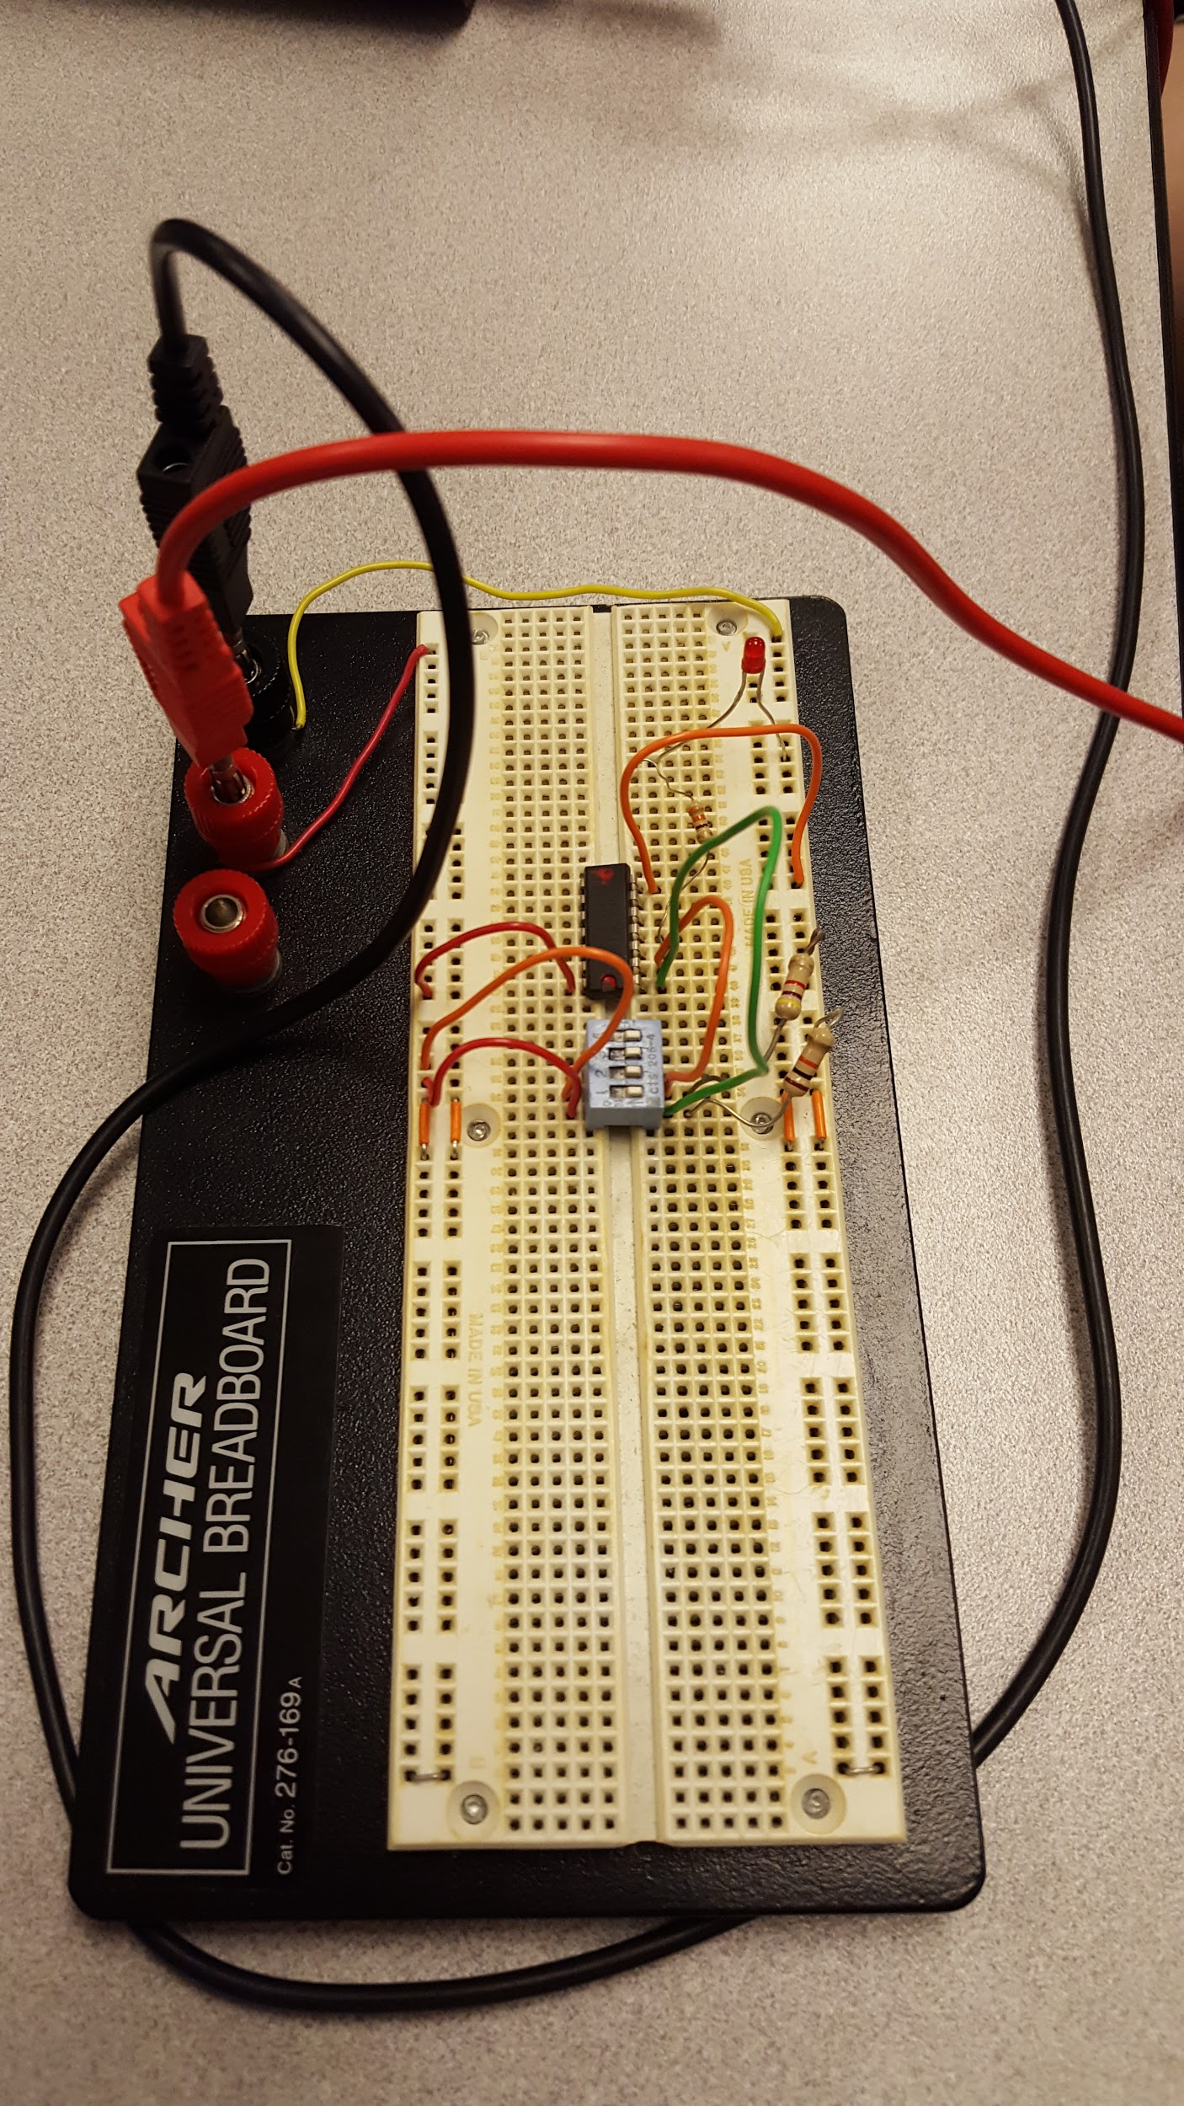

8.

|  |  |  |
| --- | --- | --- |
| Pin 1 | Pin 2 | LED State |
| 0 | 0 | On |
| 1 | 0 | On |
| 0 | 1 | On |
| 1 | 1 | Off |

This IC chip contains 4 NAND gates.

9.

|  |  |  |  |  |  |  |
| --- | --- | --- | --- | --- | --- | --- |
| A | B | C | Y | X | Y LED State | X LED State (red) |
| 0 | 0 | 1 | 0 | 0 | Off | Off |
| 1 | 0 | 1 | 0 | 1 | Off | On |
| 0 | 1 | 1 | 0 | 1 | Off | On |
| 1 | 1 | 0 | 1 | 0 | On | Off |

10. This circuit acts as an adder, more specifically, it is a 2-bit adder.

11. Picture of circuit for previous problems:

